“Music Music Collection” Database created to help to User to organize information about his (her) home music collection.

Using “Music Music Collection” Database User will be able to do:
- Record, update and edit details of albums held in home music collection- name, duration, date of release, etc.
- Keep details of the different genres of music- classic, jazz...
- Hold composers details.
- Provide details about artist.
- Extract different sets of date, e.g.:
- a list of all songs of home music collection by a given composer.
- a list of all artist and music they performed.
- Prepare reports on various things.

Tables.

To fulfil these requirements I created five tables: Album, Song, Artist, Composer, Genre.
All tables were created in Design View.

Relationships.

The Song table is related to each of the other tables. The type of relationship in each case is one-to-many.
See relationships between tables (pic.1) below.

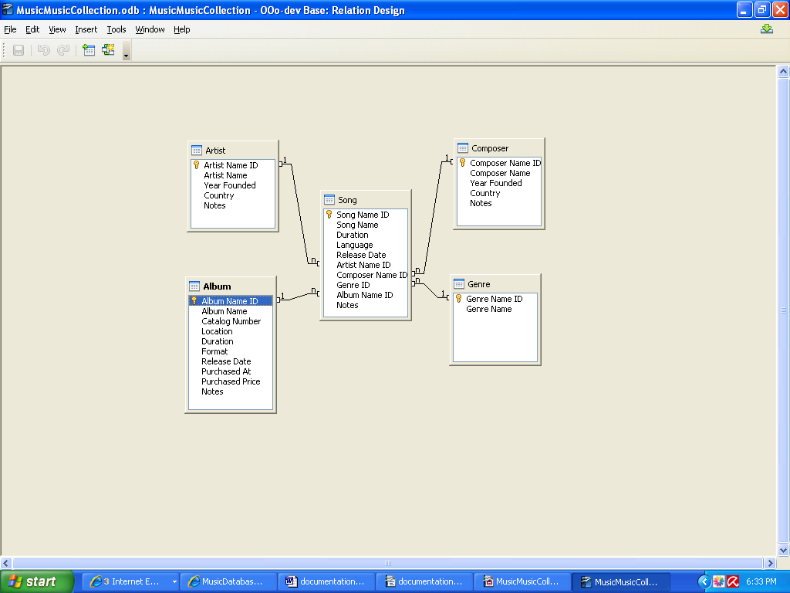
Pic.1

Queries.

Using MusicDatabase tables, we can create many combinations and many queries. I created ten qeries. Five of them are Parameter Query.
“Query Find Album”
“Query Find Artist”
“Query Find Composer”
“Query Find Genre”
“Query Find Song by Location of Album”
“Query List of Artists and Songs they Performed”
“Query List of Songs by Composer”
“Query List of Songs by Location”
“Query Locations of Albums”
“Query Song Album Artist Composer Genre”

Reports.

As we know Reports can be static or dynamic. Static reports contain the data in the selected fields at the time the report was created. Dynamic reports can be updated to show the latest data.
There are 5 Reports:
“Report List of Artists and Songs they Performed”
“Report List of Songs by Composer”
“Report List of Songs by Location”
“Report Locations of Albums”
“Report Song Album Artist Composer Genre”
All reports are dynamic.

Forms

I created one “Song Album Artist Composer Genre Data Entry Form”. This data entry form was build with No Macros. It has one main form and four subforms. “Song” table is main form.
“Composer”, “ Artist”, “Album”, “Genre” are subforms. See picture 2 below:
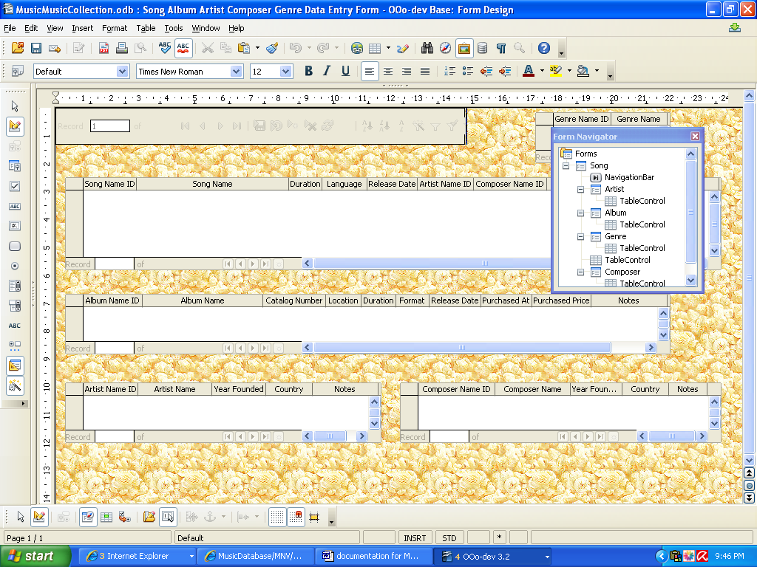
Pic.2

